Exploring Linux Logging

**Task 1: Introduction to Linux Logging**

- logging is a crucial aspect of system management and security in linux environment.
- It involves the recording of system events,processes and activities for analysis, troubleshooting and security monitoring purposes.

Key components of logging in linux systems:

- syslog: it is a standard logging facility in unix and linux systems.it collects messages from various programs and services, categorizing them based on severity levels.
- Log files: linux systems generate various log files taht contain critical information about system activities,including system events,applications logs,kernel logs and authentication logs.
- Logging levels: logging in linux systems typically involves different levels of severity,such as informational,warning,error,critical and debug. These levels help in identifying the urgency and criticality of system events and responding to issues effectively.
- Logging configuration: linux systems offer various configuration options for logging.

Logging plays a crucial role in system administration,security and truobleshooting across various computing environments.

- System administration and maintenance: logs provide real-time or historical data on system activities,including performance metrics,error messages and warning signs.
System administrators rely on this information to mointor the health of the system and proactively maintain the system to prevent potential issues.
- Security analysis: They provide essential information for monitoring and detecting security breaches, unauthorized access, and suspicious activities. Security incidents can be investigated, and preventive measures can be implemented based on log data.

- Troubleshooting and diagnostics: when issues or errors occur,logs are invaluable for diagnosing and resolving problems.administrators can analyze logs to identify the root cause of issues,whether they are related to hardware,software,configuration or user actions.

**Task 2: Linux Log Files **

Linux systems generate various log files that record system events,activities and errors.

- /var/log/syslog : it stores system-wide logs,including messages from applications and daemons.
- /var/log/messages : this file contains general system messages,including kernel and system-related logs.
- /var/log/auth.log : this file records authentication-related logs,such as user logins,authentication failures and authentication-related system events.
- /var/log/kern.log : it contains kernel-related logs,including kernel error messages,warnings and hardware-related messages.
- /var/log/cron : This file logs information about cron jobs,including scheduled tasks and their execution statuses.

**Task 3: Configuration Files **

Configuration files like /etc/rsyslog.conf and /etc/logrotate.conf are crucial for configuring the linux logging system and managing log files effectively.

Here’s an explanation of how these files are used:

- /etc/rsyslog.conf : it is the configuration file for the rsyslog service, which is a commanly used syslog daemon in many linux distributions. It controls the routing and handling of log messages generated by various services and applications to different log files or remote destinations.

- /etc/logrotate.conf : it is the main configuration file for the log rotation utility logrotate. Log rotation is essential to manage log files by compressing,archiving,and deleting old log data, preventing log files from consuming all available disk space.

Both /etc/rsyslog.conf and /etc/logrotate.conf are essential for configuring the linux logging system, defining where log messages should be stored, and managing log files efficiently. System administrators use these configuration files to customize logging behavior to meet their specific requirements, whether it’s for troubleshooting, security, compliance or resource management.

**Task 4: Log Rotation **

- Create a custom log file.
/var/log/myapp.log, using the touch command:
ex: sudo touch /var/log/myapp.log

- Next,configure ‘logrotate’ for your custom log file. Create a new configuration file for your application in the /etc/logrotate.d/ directory.
Ex: sudo nano /etc/logrotate.d/myapp

- add the following content to the file,
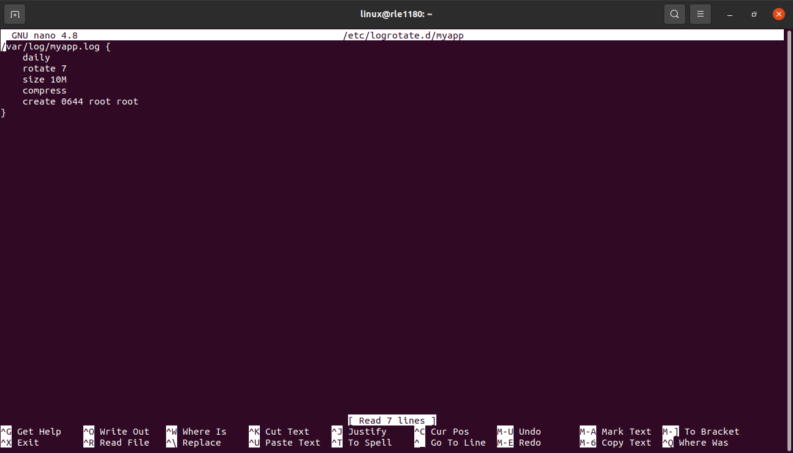
- daily : rotate the log file daily.
- Rotate 7 : keep up to 7 rotated log files.
- Size 10M : rotate the log file when it reaches a size of 10 megabytes.
- Compress : compress the rotated log files.
- Create 0644 root root : create new log files with specified permissions and ownership.

4. you can test the log rotation configuration without waiting for the daily rotation to occur by using the ‘logrotate’ command with the -d (debug) flag:
Ex: sudo logrotate -d /etc/logrotate.conf

5. if you want to force a log rotation immediately, you can use the -f flag with logrotate.
Ex: sudo logrotate -f /etc/logrotate.conf

6. to verify that log rotation you can use ‘ls’ command.
Ex: ls -l var/log/myapp*

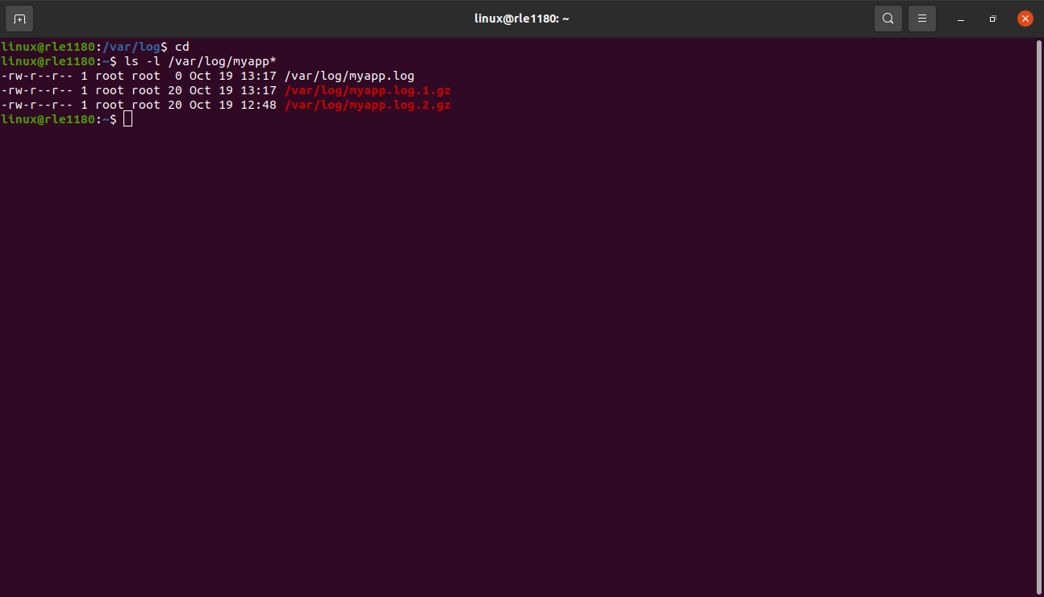

**Task 5: Analyzing Log Data (Hands-on)**

Commands like grep, awk, and sed are used to extract specific information from log files. Here are examples of how each of these commands can be used to search and filter log data, with a focus on finding failed login attempts in the /var/log/auth.log file.

- Using grep : To find failed login attempts in the ‘/var/log/auth.log’ file using grep, you can search for lines containing specific keywords like “failed” or “authentication failure”.
Ex: gerp “Failed password” var/log/auth.log
- This command searches for lines that contain “Failed password” in the /var/log/auth.log file.
- It will display lines related to failed login attempts.

2. using awk : awk can be used to extract specific columns or fields from log files. For example, you can use awk to extract the date and IP address associated with failed login attempts:
ex: awk ‘/Failed password/ {print $1, $3}’ /var/log/auth.log
This command searches for lines containing “Failed password” in var/log/auth.log and prints the first and third fields(date and IP address) from those lines.
3. using sed : sed can be used to manipulate and filter log data. For example,you can use sed to extract lines with failed login attempts and remove unnecessary information.
Ex: sed -n ‘/Failed password/ p’ /var/log/auth.log.
This sed command searches for lines containing “Failed password” in /var/log/auth,log and prints only those lines.

**Task 6: Monitoring Logs in Real-time (Hands-on)**

To view new log entries as they are written to a log file, you can use the tail command with the -f (follow) option.
This option allows you to continuously monitor a file and display new entries in real-time.
- Use the following command to monitor a log file, such as /var/log/syslog:
sudo tail -f /var/log/syslog
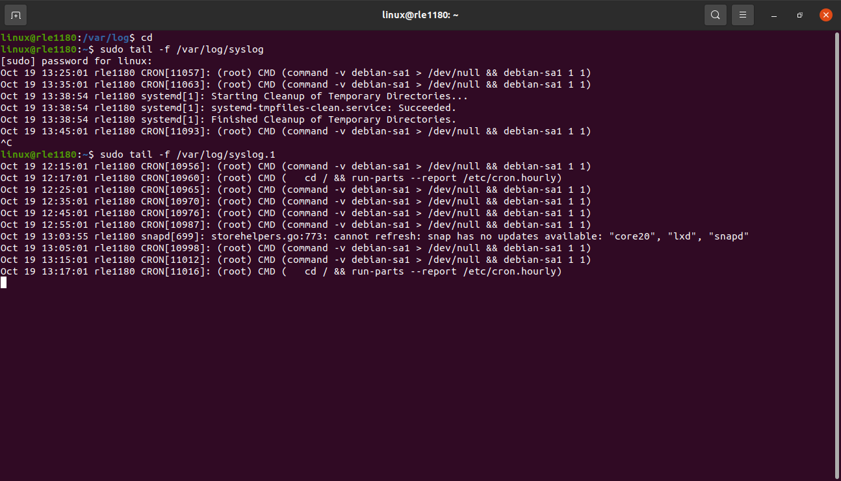
- The terminal will start displaying new log entries as they are written to the file. You ‘ll see the most recent log entries at the bottom of the terminal,and new entries will appear as they are recorded in the log file.

**Task 7: Logging with systemd (Research)**

Systemd journal is a modern logging mechanism used in many contemporary linux distributions. It is designed to replace and improve upon traditional syslog-based logging.

Systemd Journal:
- Binary Format: Systemd Journal uses a binary log format, which is more efficient in terms of both storage space and processing. Binary logs are faster to write and read, making it suitable for real-time log processing.
- Structured Data: Systemd Journal stores log entries in a structured format. This structure includes metadata such as timestamp, log source, log level, and more. It allows for efficient filtering and querying of logs based on these fields.
- Centralized Storage: Journal logs are centralized in a binary format database under the /var/log/journal/ directory. This centralization simplifies log management, backup, and searching.
- Integration with Systemd: Systemd Journal tightly integrates with the systemd init system, which is common in many modern Linux distributions. It can capture logs generated during the system boot process, which traditional syslog may not capture.
- Real-time Journalctl Utility: The journalctl command is used to query and display logs from the systemd journal. It allows for real-time log viewing and offers advanced querying capabilities, such as filtering by time range, severity, or source.
- Data Retention Policies: Systemd Journal supports data retention policies, which allow administrators to define how long logs should be stored and when they should be rotated or pruned.
Traditional Syslog-based Logging:
- Text-Based: Traditional syslog-based logging primarily uses plain text log files. Each log message is stored as a separate text line in log files, making it less efficient for both storage and processing.
- Structured Data (Limited): While syslog-based logs can include structured data, this is not a strict requirement. Many log messages are unstructured text, making it more challenging to extract meaningful information from logs.
- Distributed Storage: In traditional syslog-based logging, log files are typically scattered throughout the file system. Log rotation and retention policies may vary from one log file to another.
- Separate Services: Traditional syslog typically consists of separate services (e.g., rsyslog or syslog-ng) responsible for collecting, processing, and forwarding log messages. These services can be configured independently.
- Log Rotation and Management: Log rotation and management are usually managed through configuration files in /etc/logrotate.d/ and /etc/syslog.conf. The retention of log data may require manual configuration.
- Basic Command-line Utilities: Utilities like grep, awk, and sed are used for log analysis in traditional syslog-based logging. Advanced querying and filtering may require more complex scripting.

**Task 8: Logging Tools (Hands-on)**

rsyslog is a widely used logging system for linux that can be configured to collect,process,and forward log data to various destinations.

- Install rsyslog:
ex: sudo apt-get install rsyslog

- configure rsyslog:
Edit the rsyslog configration file, located at /etc/rsyslog.conf.
Modify configurations to forward log data to a remote syslog server .
Ex: *.* @remote-syslog-server:514

Replace remote-syslog-server with the IP or hostname of your syslog server. This configuration forwards all log messagesto the remote server.

3. restart rsyslog:

- after making the configuration changes,restart the rsyslog service:
ex: sudo service rsyslog restart

4. verify log forwarding

- you can verify log forwarding by checking your syslog server for incoming log data from your linux system.

